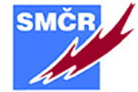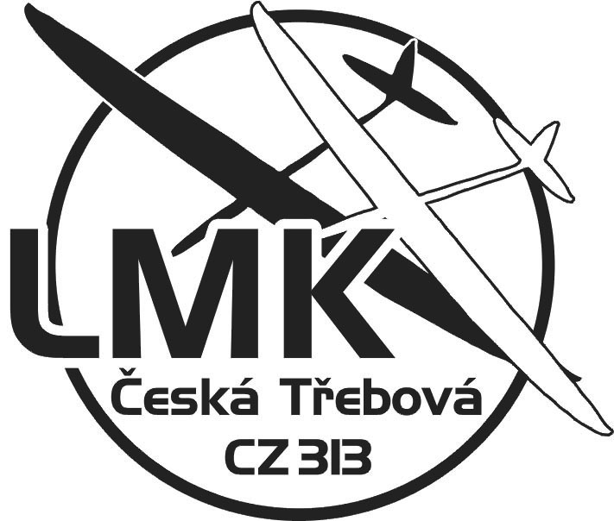
International competition model gliders category F5J
WORLD CUP 2018
Eurotour
INTERTOUR
Competition: Radio-controlled model gliders category F5J
Date of competition: 26th and May 27, 2018
Age category: seniors, seniors 60+, juniors
Organizer: Leteckomodelářský klub Česká Třebová
Contact: http://www.lmkct.cz
Competition Director: Mgr. Václav Jeništa
The main referee and starter: Ing. Miroslav Minařík
Jury: CZE, SVK, AUT
Airports: Models airport Sázava u Lanškrouna 49.9083353N, 16.6428539E
Condition of participation: Starting the competitors with a valid license to FAI r. 2018.
Entry fee: Seniors 900, - CZK (36, - €) Seniors 60+ 650,- CZK (26, - €), juniors and students 500, - CZK (20, - €)
Applications: The e-mail alois@ahracz.eu or at www. stoupak.cz to Wednesday, 16. May 2018.
The deposit can be sent to the account LMK account number 213835394/0300. Variable symbol is the license number. When logging indicate 3 used frequency (channel). It is possible payment upon presentation.
Presentation and acceptance of models: Friday, May 25 from 16.00 to 20.00 hrs., Saturday, May 26 from 7.30 to 8.30 pm.
Program: Saturday 9.30 pm. Initiation, 10.00. - 19.00 hrs. Competition flights.
Sunday 9.00 pm. - 15.00 hrs. competition flights.
Announcement of results: 1 hr after the last flight ..
Rules: FAI 2018
Evaluation of the results: Number 7 qualifying rounds, the final rounds 3rd
Protest: served immediately, at the latest after the flight group chief referee together with a deposit of CZK 750.- (30, - €) If granted Stake returned.
Messing: at the airport. Possibility to purchase meal tickets for 300,- CZK (12,00 €) for 3 meals. (lunch, dinner, lunch)
Accommodation: There is a camping area on the airport premises with facilities for free.
Correspondence: Hrabáček Alois Albrechtice 77, 563 01 Lanškroun,
tel. + 420 724090298, e-mail alois@ahracz.eu
Hrabáček Alois - Chairman LMK
Accommodation options:
http://www.countrysteak.cz
http://www.hotelbravo.cz
http://www.senha.cz

